**Press release***Trade press*

**Julia Keller is Kautex Maschinenbau's new CFO**

**Kautex Maschinenbau, based in Bonn, Germany, is driving its change process forward with big steps. Julia Keller is responsible for commercial company management, as the company's CFO, since April 2020. She is a business studies graduate, who specialized in finance and human resources. Julia Keller takes over from Frank Röhrlein, who will be retiring.**

Keller is a proven expert in process optimization and lean management and was most recently head of finance and authorized signatory at a company in the construction engineering sector. She has been working with Frank Röhrlein at Kautex Maschinenbau, to prepare for taking over from him, since September 2019. She already took over management of the Human Resources division in January of this year, and will also continue in that position. With these two positions, she is taking on a central role in the company management.

Thomas Hartkämper, Kautex Maschinenbau's CEO, is pleased to have gained another change expert for his management team: "Personally, I am convinced that our team is massively strengthened by being heterogeneous. This is essential in company management, in particular. Julia Keller's experience in change management, gained over many years, is just one aspect of that. Another is that she can demonstrably lead improvements in a finance and HR department via her process management skills and exceptional ability to focus on customers. All that makes her a unique person to take on the role of CFO. For this reason, we are extremely pleased that we have been able to convince her to join Kautex's management team."

Julia Keller has set herself some clear objectives: "Stable funds, transparency achieved through clear processes and a consistent focus on customers and service are decisive factors in achieving a successful change process. Staff development and open communication create room for a changing corporate culture. In my opinion, listening, inspiring, supporting and challenging are core factors in successfully implementing change in the company."

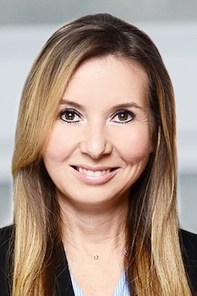

**Julia Keller**

**About Kautex Maschinenbau**Eight decades of providing its customers with innovative products and services have turnedKautex Maschinenbau into one of the world's leading companies in extrusion blow molding technology. With customers that include major automobile manufacturers and suppliers, as well as companies working in the packaging industry. All of them have come to rely on the knowledge and experience of a brand that stands for both quality and reliability. In addition to its HQ in Bonn, a Customer Service Center in Berlin and regional offices in the USA, Russia, China, Italy, India, Mexico and Malaysia, Kautex Maschinenbau operates an extensive global network of service and distribution offices. **Contact details**

**Christian Kirchbaumer**  
Head of Marketing Communications

**Kautex Maschinenbau GmbH**  
Kautexstr. 54  
53229 Bonn  
Germany

T +49 228 489370

christian.kirchbaumer@kautex-group.com